|  |
| --- |
| **Case Study** |
| **Cracking the Assembly Code** |
|  |
| School assembly revolves around the idea of bringing the entire school together at the beginning of the school day. It brings together students, teachers, and staff together which impart a sense of unity and belongingness. This assembly gathering underscores that every member of the school community has a role to play, creating an environment where every individual is given a platform to groom and nurture their inherent potential and capabilities. |
|  |
| **Smti. K. Munenle Tep, AHM** |
|  |
|  |

**School Leadership Academy,**

**Nagaland**



**Cracking the Assembly Code**

**Key Area- 1: Perspective on School Leadership**

**About the Series**

*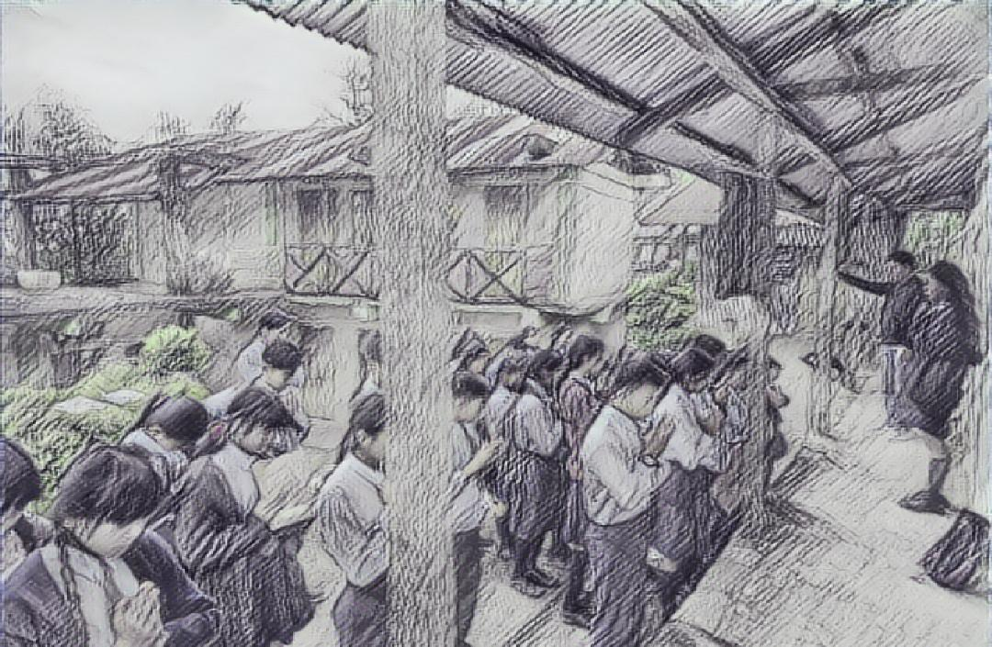This Case Study presents the challenges faced by serving school leaders in Nagaland. The Case study is linked to one of the Key Area given in the Handbook for 30 Days School Leadership Development Programme developed by NCSL, NIEPA, New Delhi. The case study describes a problem faced by the School and the strategies used by the School Head to resolve it.*

**SCHOOL PROFILE**

**Name of School Head:** Smti. K. Munenle Tep, AHM

**School Name:** GHS, TseminyuTown

**Location:** Tseminyu Town, Nagaland

**Phone Number:**  8575271366

**Email Id:** mnleteppeno77@gmail.com

**Number of Students:** 104

The Govt. High School Tseminyu New Town located near Town Hall, it was upgraded to High School status from GMS in the year 2012. The GPS section located few meters away from the High School building was merged to GHS during school rationalization. Presently, GHS is being run in two separate building with Class 6-10 in one building and GPS section in other building. The number of students’ enrolment has been increasing each year.

**The Present Scenario of the School**

**Strengths:**

The school is easily accessible for the students in Tseminyu town and the nearby villages. The school caters to the need of economically disadvantage section of the society.

**Weaknesses:**

Children of low economic group form the core of the school population.

**Opportunity:**

Children from such environment have low self esteem and lack confidence since they lack opportunity of social exposure and interaction in such scenario school is the only place that can help in nurturing their various developmental needs.

**Threat Analysis:**

The school is facing severe shortage of teachers and staff due to non replacement on death, retirement, promotion and transfer. The effectiveness of the school functioning are hampered to large extend due to this trend.

**The description of community-cultural pressures; values, needs and expectations; skills, chief occupation**

Majority of the school students are from the Rengma tribe of Nagaland because the population of Tseminyu district is Rengma. Like all tribal community, the Rengmas also have rich cultural and traditional heritage and the main occupation of the people is agriculture.

The students from affluent families mostly opt for private schools and other institution and we receive mostly average and low performing students but the school continues to strive for imparting quality education.

**PROBLEM: Cracking the Assembly Code**

The idea for ‘Cracking the Assembly Code’ occurred during One Month Certificate Course on School Leadership Development Programme conducted by SLA, Nagaland. During the programme she thought ***“What are the needs and challenges of my students?”*** She felt that as a school leader, her role was not only to lead the school but also to nurture the students to their fullest potential. It struck her that, ***“One platform to understand and nurture the developmental needs of my students is morning assembly.”***

The present case study deals with an activity which the school already practices but she tries to add more component to the present situation through which the school could cater to the various developmental needs of the student. Under her guidance and assistance the students were given a platform to develop their innate potential.

A vibrant school morning assembly inculcates confidence in students, fosters leadership skills, character development, and creativity, while building a feeling of community. Done well, assemblies contribute to a rich school ethos that validates the school's identity and goals.

**INTERVENTION**

**The Assembly Journey**

Smti. K. Munenle Tep, joined as Asst Headmistress and the head of GHS Tseminyu Town, New Town in January 2023 and also in the same year she completed the one month certificate course in SLDP conducted by SLA, Nagaland. Understanding the scenario of the school and student, under her leadership she ventured to improve the school in her own capacity, she decided to use morning school assembly as a platform to impart discipline in the life of the student and also to cultivate self confidence in student.

For this, she called for a staff meeting and formed a “Morning Assembly Committee”. Together they set up the strategy for the Morning Assembly. All staff and the students were expected to participate and follow the routine.

School Assembly was used as catalyst in mobilizing the student discipline and self confidence. She initially initiated by re-organizing the assembly committee where all the academic and non academic staffs of the school were involved. The assembly schedule was restructured and new component were added where involvement and participation of the student were encouraged. She felt that as a school leader, her role was not only to lead the school but also to nurture the students to their fullest potential.

But after two months, the school head began to see discrepancies in the way in which the daily morning assemblies were being held. Some days, the morning assembly started late, disrupting the daily schedule and caused delays in classroom activities. The level of student involvement in morning assembly activities did not cater to all the students. Some of the students did not actively engage or participate in their designated responsibilities. Therefore, the school head decided to set a mechanism to address the issue by doing two things. The two things she did were:

1. Conduct leadership training for the Morning Assembly Committee members.
2. Developed a feedback mechanism and collect feedback from the school staff and students.

**THE OUTCOME**

Within a month time, the student involvement and participation could be seen and felt. Assembly worked as a platform where every child was given an opportunity to exhibit their innate potential as well as develop their personalities.

The leadership training imparted to the Morning Assembly Committee members enhanced the organizational, communication and coordination skills of Committee members and thus, the Morning Assembly was conducted with more activities like:

* *Short talk from community members on culture and tradition.*

This made the students become aware of their rich cultural heritage and the importance to preserve them.

* *Short speech on career, self employment, awareness of diseases, substance abuse etc. from teachers.*

These speeches gave more knowledge to the students beyond their textbooks.

* *News reading, extempore speech, singing, prayer etc. by the students, where every class and individual students were given opportunity to participate.*

This activity helped the students to be more pro-active in participating in school activities and explore their hidden talents. It also helped introvert students to overcome their fear of standing in front of a crowd and most importantly in helped in boosting the self-confidence of many students.

Monthly review meeting were held as a feedback mechanism where students and staff anonymously share their observations and feedback. These feedbacks helped the committee members to assess the effectiveness of the morning assembly and make modification according to the feedbacks.

**CONCLUSION**

School assembly revolves around the idea of bringing the entire school together at the beginning of the school day. It brings together students, teachers, and staff together which impart a sense of unity and belongingness. This assembly gathering underscores that every member of the school community has a role to play, creating an environment where every individual is given a platform to groom and nurture their inherent potential and capabilities. The school Head understanding the context of the school and students used the Morning Assembly as platform to cater to the developmental needs of the students and improve the school as a whole.

**Reflective questions:**

1. What challenges did the school face in designing and executing morning assembly programmes? How do you address such issues?
2. How can morning assemblies be used as a platform to cater to a student’s developmental needs? Reflect with your staff and students on how this can be achieved
3. How will you monitor and evaluate the effectiveness of morning assembly to understand student’s developmental needs and progress and to ensure consistency of commitment and delivery?
4. **A Celebration:** While morning assemblies can be an interesting and valuable platform to enhance the overall development of children, they can be a challenging platform to sustain. How well did the school head go about setting up school assemblies? What was worthy of praise about how she acted when she realized that the initiative had stalled?